<https://egerialearning.com/terms>

nella prima riga la data è da cambiare con: 25 novembre 2019

nei punti sotto invece bisogna tenere solo il punto

1.Account, mentre gli altri sotto vanno tolti e sostituiti con questi:

2.Lifetime access to the platform

By joining the fantastic Egeria training ecosystem, we promise you will be a part of it for life! Yes, you read that right. By winning the chance to be a member for life, you can take advantage of our trading paths and resent them as many times as you want.

3.Course contents

The training content you will find will be of the highest quality. You will discover how to become a great financial trader and develop an entrepreneurial and winning mindset. You will find content that will range from knowledge of financial markets (forex, Stocks, Crypto etc.) to touching macroeconomic content. We give you incredible news: we are working to expand Egeria to countless other courses of another kind.

4.Legal rights of Egeria e-learning

Users of the site must be informed that this product has been protected with sophisticated "anti-piracy" systems. Everything contained within the website, documentation, content, text, images, logo, artistic work and graphics are the property of Wize srls, are protected by copyright as well as by intellectual property rights. It will therefore be absolutely forbidden to copy, appropriate, redistribute, reproduce any sentence, content or image on this site because it is the result of the work and the intellect of the author himself. It is forbidden to copy and reproduce the contents and images in any form. The redistribution and publication of content and images not expressly authorized by the author is prohibited. Copyright ©️ 2000 - 2020 Wize srls · all rights reserved.

5.Legal terms

This site is for educational purposes only. It must therefore not be understood in any way as an operating investment advice or as a solicitation to raise public savings. The results presented, real or simulated, do not constitute any guarantee with respect to hypothetical future performances. Speculative activity on the financial markets involves considerable economic risks and whoever carries it out does so under their own and exclusive responsibility; therefore, the authors assume no responsibility for any direct or indirect damages relating to investment decisions made by the reader. The navigator, therefore, exempts Wizesrls, its partners and collaborators, within the limits of the law, from any liability in any case connected or deriving from this website.

<https://egerialearning.com/privacy>

stessa cosa da cambiare la data nella prima riga con 25 novembre 2019

poi i punti sotto vanno eliminati e sostituiti con questi:

1.What data we get

We at Egeria Learning we will collect your personal information to better manage your profile, giving you an experience of extreme comfort and precision.

2.What we use your data for

Your data will be used to create a personal profile where you can check your progress in the purchased courses, monitoring your progress day by day

3.Who we share your data

Your data will in no way be shared with other people without your consent, but they will be taken with extreme care and confidentiality.

4.Specific jurisdiction and rules

These terms and conditions apply to all visitors and / or users and / or customers and / or students and / or authors and / or buyers who sail on the portal and / or access the portal and / or use the portal. Therefore, browsing and / or using the portal, visitor and / or user and / or customer and / or employee and / or author and / or buyer recognizes to have read, understood and accepted these terms and conditions, which also recognizes of Being constrained and is committed to respecting.

In light of the above, it is expressed invitation to read in full and carefully the terms and conditions and, if not shared, to abandon the portal and not to use services / products.

The supplier reserves the right to modify and / or integrate these Terms and Conditions at any time and without notice, giving communication to its home. In this case, changes will be effective to the effects of law, without the need for specific and further approval.

The use of the portal at a time after the contribution of these changes and additions implies the complete acceptance by the visitor / user / buyer / Courseist / customer / author of the new terms and conditions. Therefore, the visitor / user / buyer / coursel / customer / author to constantly verify any changes and additions made to the terms and conditions from time to time and not to use the portal if he does not share or do not intend to accept, too Only partially, the new terms and conditions.

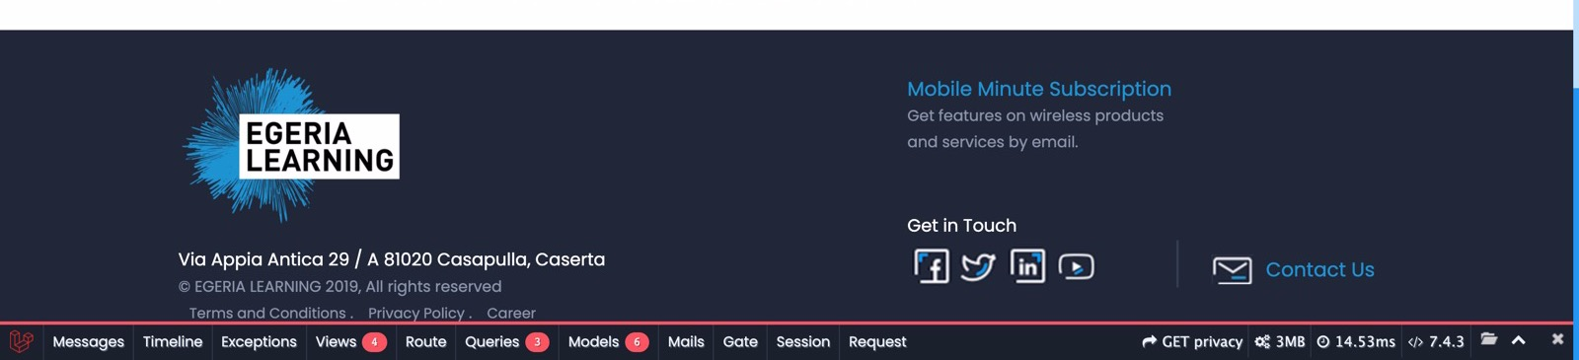

nella barra sotto dei contatti su get in touch vanno tolte tutte le icone e messa solo la mail: [wizesrls@outlook.it](mailto:wizesrls@outlook.it)

nella home da cambiare ci sono 3 cose:

la sezione About us:

WIZE is the elite financial training academy born in Italy in 2019.

Our company was born from the union of young traders with proven experience in the sector. Founded by Marco Adamo, former Barclays financial advisor and expert in technical analysis and behavioral finance. Wize's goal is to give awareness, self-control and impeccable preparation to face the difficult world of financial derivatives. According to our philosophy, there is talent and propensity in anyone; no matter who you are, where you come from and what you do in life, everyone has this unspoken talent. Our mission? Extract that talent, let you notice it, let you live it and then ... let you use it!

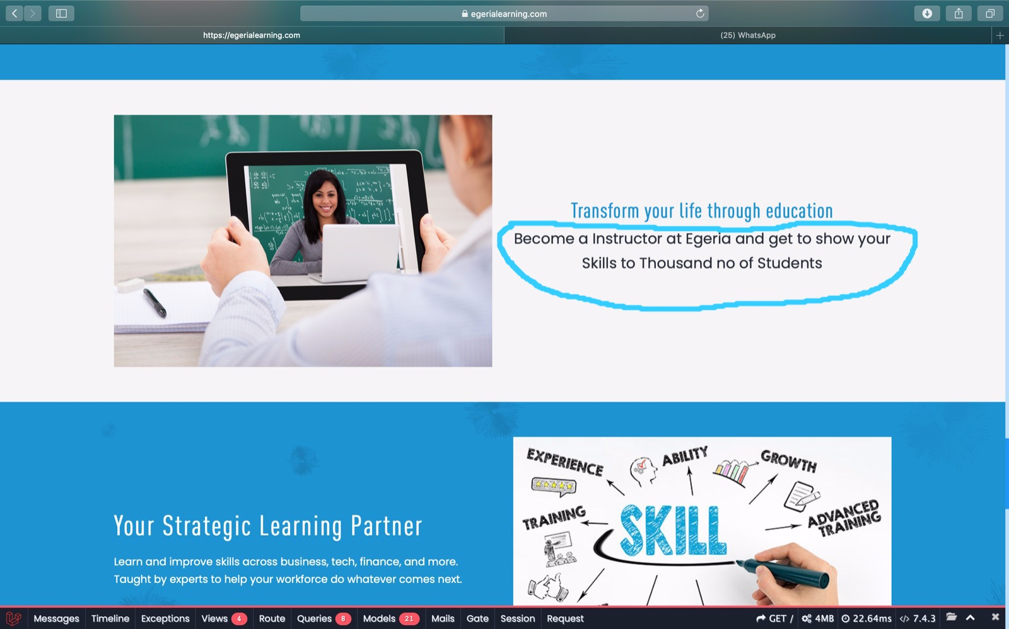

poi sempre nella home cambiare questa frase con: Turn your life upside down with egeria

infine cambiare in fondo alla pagine le recensioni con queste (foto comprese se possibile):

I started my career from scratch and that made me feel uncomfortable. Banquet that I would not be able to reach great heights, but after six months there has been a great change in me. I'm really pleased with how the Wize program has given me a 360 degree training, confidence in myself and above percentages of income that I never expected to reach.

Raffaele Savastano

I joined Wize exactly one year ago. In addition to the fascinating journey and unconventional proposed academy, what struck me was the human touch. I was never left alone, I had a chance to be followed at any time and the results came as an obvious consequence of this assistance one to one very unique. Currently I have realized the dream of entering FTMO (financial institution). Thanks guys, you're amazing!

Andrea Roberto

An academy to nothing short of perfect! The team is accurate, available, prepared and you will never hear any one does. In this school there is positive energy so that it is virtually impossible not to be involved. Believe me ... get the results is really the norm in Wize!

Matteo Barba

I can testify with three words: available, transparent and tireless. For me, joining Wize, it has meant not only learn the best job in the world, but I also learned to believe in myself. Here you do not just learn to trade here ... it grows and you literally turns into another person. Thanks to the mental and spiritual techniques of Mark Adamo, I cut down all limits. Thank you so much!

Vincenzo Carbone

Availability is the word that best describes this fantastic company. I can only say that Mark was willing to let me lessons on Saturday night outside office hours. Say no more! Thank you very much.

Danny

I am a student of Economics. In Wize I had to question many beliefs, logical and academic information about the financial world. It was surprising to find that speculation is really a world apart from the long-term investments. It was an incredible experience. Thank you guys!

Tony Pezzella